# Capstone Task 2

**Project: Student Database Management System(PostgreSQL)**

**1. Database Setup**

CREATE DATABASE student_database;

\c student_database;

CREATE TABLE student_table ( Student_id SERIAL PRIMARY KEY, Stu_name TEXT, Department TEXT, Email_id TEXT, Phone_no NUMERIC, Address TEXT, Date_of_birth DATE, Gender TEXT, Major TEXT, GPA NUMERIC, Grade TEXT CHECK (Grade IN ('A', 'B', 'C')) );

**2. Data Entry**

-- Inserting 10 sample records into student_table

INSERT INTO student_table (Stu_name, Department, Email_id, Phone_no, Address, Date_of_birth, Gender, Major, GPA, Grade) VALUES ('John Doe', 'Computer Science', 'john.doe@example.com', 1234567890, '123 Main St, Anytown', '1995-05-15', 'Male', 'Computer Science', 3.75, 'A'), ('Jane Smith', 'Electrical Engineering', 'jane.smith@example.com', 9876543210, '456 Elm St, Othertown', '1996-08-20', 'Female', 'Electrical Engineering', 3.85, 'A'), ('Michael Johnson', 'Physics', 'michael.johnson@example.com', 5551234567, '789 Oak Ave, Somewhere', '1994-11-10', 'Male', 'Physics', 3.60, 'B'), ('Emily Brown', 'Mathematics', 'emily.brown@example.com', 7779876543, '321 Pine Blvd, Nowhere', '1997-02-28', 'Female', 'Mathematics', 3.95, 'A'), ('David Wilson', 'Biology', 'david.wilson@example.com', 3334445556, '654 Cedar Rd, Anyplace', '1993-07-05', 'Male', 'Biology', 3.40, 'B'), ('Sarah Lee', 'Chemistry', 'sarah.lee@example.com', 2223334445, '987 Maple Ln, Everywhere', '1998-04-12', 'Female', 'Chemistry', 3.55, 'B'), ('Robert Garcia', 'History', 'robert.garcia@example.com', 6667778889, '741 Birch St, Nowhen', '1995-09-17', 'Male', 'History', 3.25, 'C'), ('Jessica Martinez', 'Psychology', 'jessica.martinez@example.com', 9998887776, '852 Walnut Dr, Anyville', '1996-01-03', 'Female', 'Psychology', 3.70, 'A'), ('Christopher Nguyen', 'Economics', 'christopher.nguyen@example.com', 4445556667, '963 Sycamore Ave, Somewhen', '1994-12-25', 'Male', 'Economics', 3.80, 'A'), ('Amanda Robinson', 'Sociology', 'amanda.robinson@example.com', 1112223334, '159 Pineapple Cir, Elsewhere', '1997-06-30', 'Female', 'Sociology', 3.45, 'B');

**3. Student Information Retrieval**

Develop a query to retrieve all students' information from the "student_table" and sort them in descending order by their grade.

SELECT * FROM student_table ORDER BY Grade DESC;

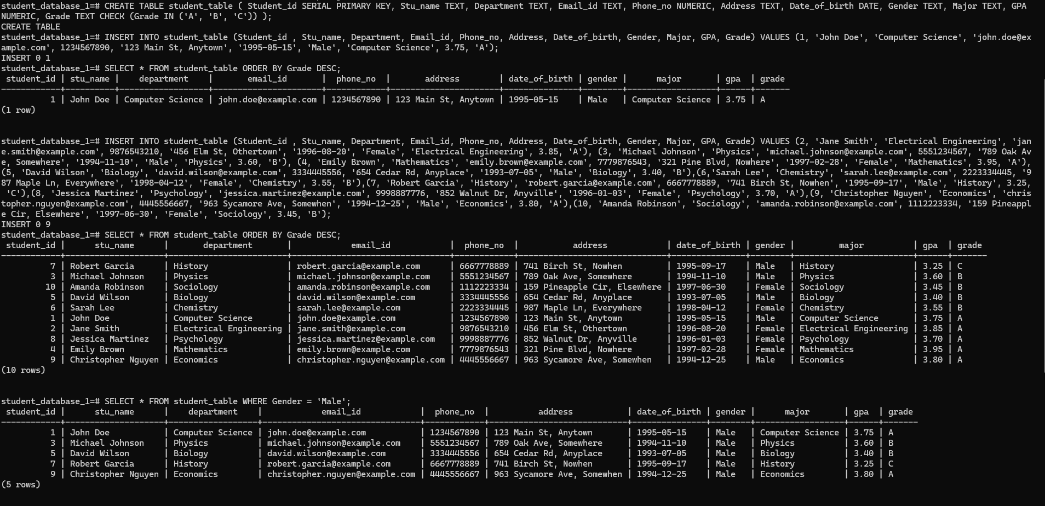

**4. Query for Male Students:**

SELECT * FROM student_table WHERE Gender = 'Male';



**5. Query for Students with GPA less than 5.0**

SELECT * FROM student_table WHERE GPA < 5.0;

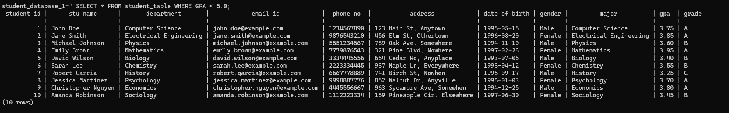

**6. Update Student Email and Grade**

Write an update statement to modify the email and grade of a student with a specific ID in the "student_table."

UPDATE student_table SET Email_id = 'updated.email@example.com', Grade = 'A' WHERE Student_id = 3;

**7. Query for Students with Grade "B"**

Develop a query to retrieve the names and ages of all students who have a grade of "B" from the "student_table."

SELECT Stu_name, EXTRACT(YEAR FROM AGE(Date_of_birth)) AS Age FROM student_table WHERE Grade = 'B';

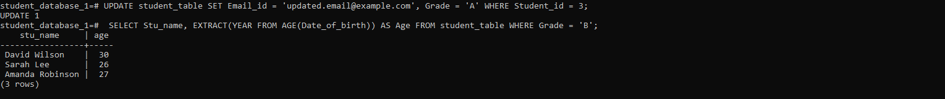

**8. Grouping and Calculation**

Create a query to group the "student_table" by the "Department" and "Gender" columns and calculate the average GPA for each combination.

SELECT Department, Gender, AVG(GPA) AS Avg_GPA FROM student_table GROUP BY Department, Gender ORDER BY Department, Gender;

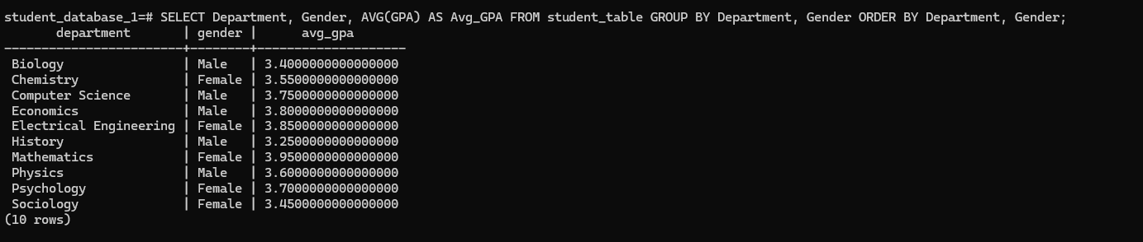

**9. Table Renaming**

Rename the "student_table" to "student_info" using the appropriate SQL statement.

ALTER TABLE student_table RENAME TO student_info;

**10. Retrieve Student with Highest GPA**

Write a query to retrieve the name of the student with the highest GPA from the "student_info" table.

SELECT Stu_name FROM student_info WHERE GPA = ( SELECT MAX(GPA) FROM student_info );

